Gold Dot 5.7x28mm
Insist on more from your 5.7x28mm. Speer® has broken new ground for the cartridge with an all-new Gold Dot® load—the first 5.7x28mm round specifically designed for self-defense. Like all Gold Dot ammunition, the bullet is built using Speer’s exclusive Uni-Cor® method. The jacket is bonded to the core one atom at a time, virtually eliminating core-jacket separation and creating a projectile that’s accurate, tough and consistent through all common barriers. High-quality brass, reliable primers and specially formulated propellant produce optimal feeding and ballistics in 5.7x28mm firearms.

Features & Benefits
- First 5.7x28mm round designed specifically for self-defense
- Consistent penetration and expansion through common barriers
- Extremely uniform jacket maximizes accuracy
- Gold Dot technology virtually eliminates core-jacket separation
- 50-round box

Part No. Description UPC MSRP
25728GD 5.7x28mm 40 grain, 50-count 6-04544-66237-5 $51.99

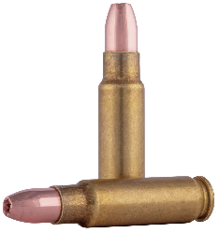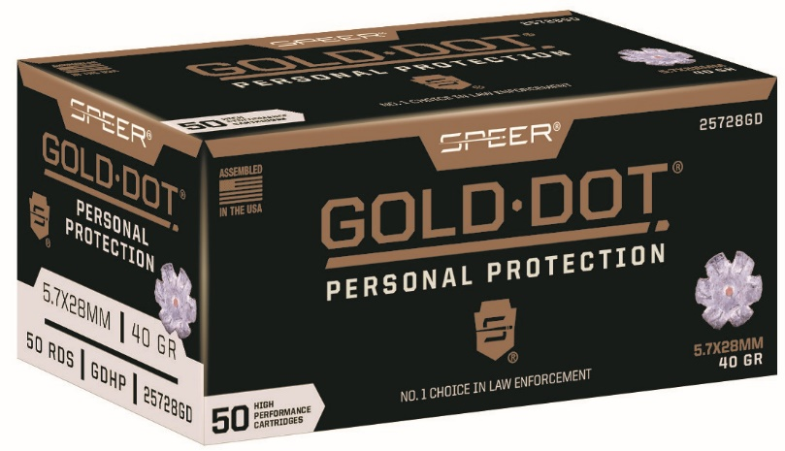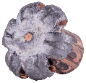

* Functions in many firearm platforms including the FN handgun. Not for use in the rotating feed design of the FN P90 magazine.

